6. Statistical Measures of Circular Distributions
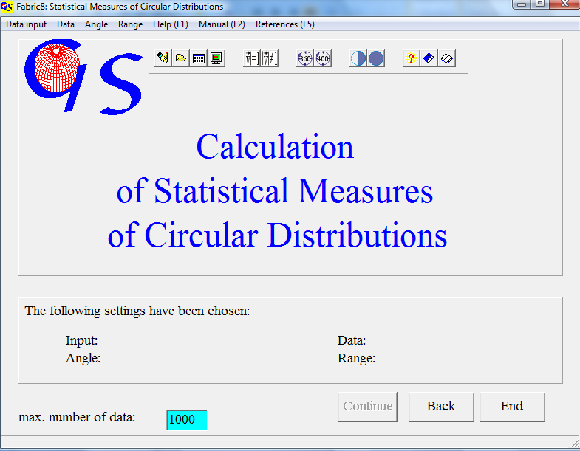
Fig. 1

This program (Fig. 1) calculates statistical measures of circularly distributed orientation data. (i.e. strike lines, lineations in remote sensing data, flow direction of rivers). The data input (Fig. 2) can be manually, from a file, from an Excel sheet, or from a picture (aerial photo, satellite image, or digital elevation model).

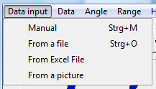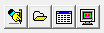
Fig. 2

With the option “Manual” you have to fill in all measures manually. With the option ”From a file” files are chosen from a folder. Input from an Excel sheet is the same as in program 2, 3, and 4.
When the option “From a picture” is chosen, an aerial foto, satellite image, or other image that contains foto-lineations is displayed on the screen. The image must be a bmp, gif, tif, jpg, wmf, emf, or png file.
The data may be pure directions without a defined length (i.e. strike lines) or they may have a defined length (i.e. lineations on a satellite image). Therefore you have to choose the type of data in the menu “Data” (Fig. 3).

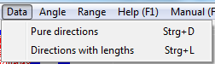 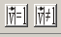 Fig. 3

When data input is from an image, data are directions with lengths and the menu “Data” becomes inactive.
The menu „Range“ (Fig. 4) differentiates between data without polarity (i.e. strike lines) and those with polarity (stream lines). The first data type can be described in the angular range between 1° and 180°, the second one needs 1° to 360°.
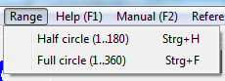 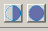 Fig. 4

The extensions for files of these different types of data are:

.STR no polarity, pure directions
.LST no polarity, Directions and lengths,
.AZI with polarity, pure directions,
.LAZ with polarity, directions and lengths.

Manual input, input from a file, and input from an Excel sheet are the same as in the previous programmes.
When you choose input from an image, the form in Fig. 5 appears. In the menu “Import picture” (Fig. 6) you decide whether the image is imported from the clipboard or from a file.

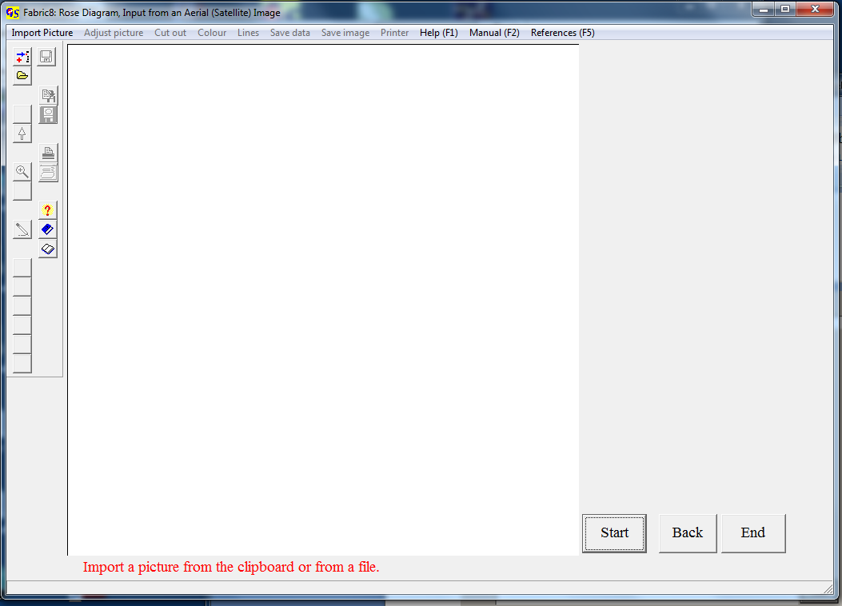
Fig. 5

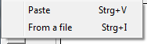
Fig. 6

When “From a file” is chosen, a croll list with the allowed graphic formats appears (Fig. 7). These are *.BMP, *.GIF, *.TIF, *.JPG, *.Wmf, *.EMF, and *.PNG.

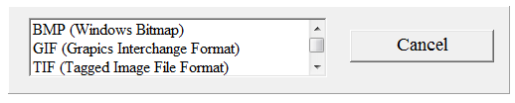
Fig. 7

The imported picture (Fig. 8) can be rotated (Menu “Adjust picture”) in case that the north direction is not in an upright position, if this is not the case, you click on ‘No correction’.
In the next step (Menu “Cut out”) you either cut out a part of the image, or use the whole image.

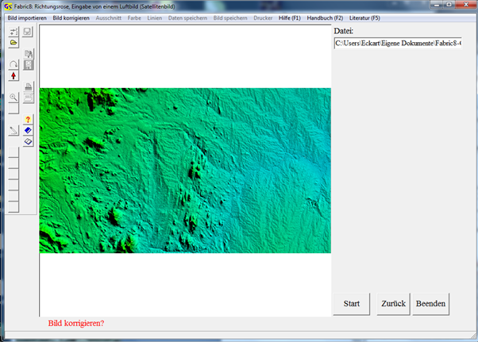
Fig. 8

Now data can be collected by clicking on the ends of photo-lineations with the left mouse button (Fig. 9). If you have chosen the range “Half circle”, the data have no polarity, so it does not matter on which end of the lineation you click first. When rhe range is “Full circle” you have to click on the vector arrow first.
The graphic can be saved and/or printed at any time.

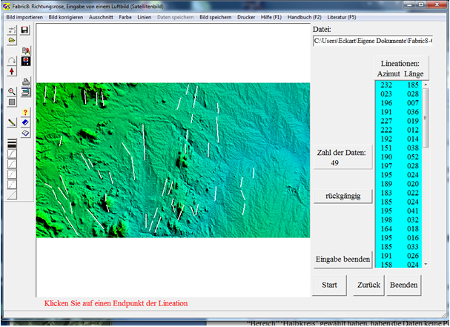
Fig. 9

After pressing the button "Terminate input" the menu "Save data" is active, and the button "Measures" appears. This button brings you to the next form in which the statistic parameters are shown (Fig. 10).

The following measures are calculated::
1. Vector sumSummenvektor
2. Normalized vector sum
3. Preferred orientation
4. Vector mean
5. Skewness of the distribution
6. Kurtosis of the distribution

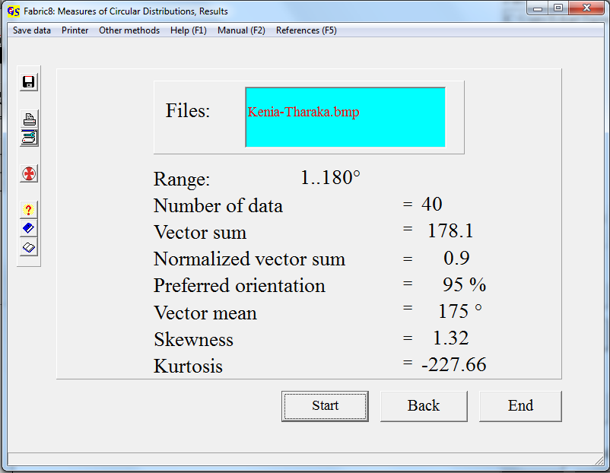
Fig. 9

The measures are calculated for a circular normal distribution, i. e. von Mises distribution (VON MISES, 1918), described in detail by WALLBRECHER ( 1986:124ff).
The vector sum (R) is the resultant length of the vectorial addition of all data:

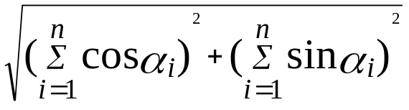

α = Azimuth

The normalizd vector sum has the form:

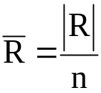
and the preferred orientation is calculated like this:

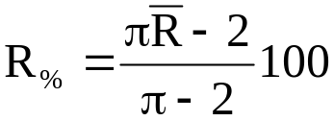

The vector mean is the direction of the vector sum. It has the form:

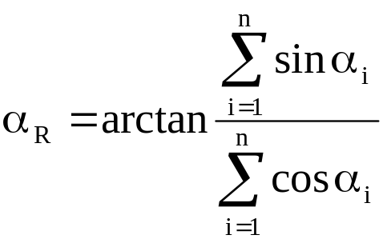
α=Azimuth

Skewness and Kurtosis have the same meaning as in normal statistics.

With The menu "Other methods" you can jump to a rose diagram (program 7).

